New University logo


|  |  |  |  |
| --- | --- | --- | --- |
| Academic Year | 2022 | | |
| Semester | Fall | Winter | Summer |
| Course Code - Name | CSCI 2010U – Data Structures | | |
| Instructor | Dr. Razi Iqbal | | |
| Assessment | Exercise 5 |  | |

**Question 1 (Basic)**

This exercise tests your knowledge of recursion in Java.

Write a Java program that creates a class Driver which has a main method that calls public static void showFibonacci**(**int n**)** method. showFibonacci(int n) then calls public static int fibonacci**(**int n**)** method which actually returns a Fibonacci number at an index provided to this function as a parameter (we did this function in class as well). The purpose of showFibonacci(int n) is to show n Fibonacci numbers where n is the number provided to the function as a parameter. You are also required to find Big-O time complexity of both these functions.

Below is the screenshot of the expected output of this program:

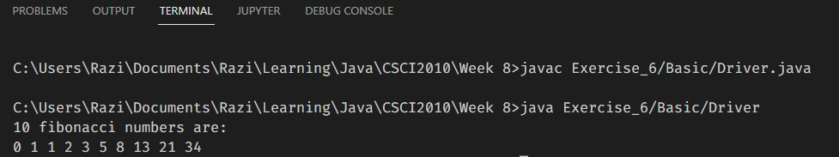

Try to run the program using commands in terminal to get more practice.

**Question 2 (Intermediate)**

This exercise tests your knowledge of recursion in Java.

Write a Java program that creates a class Driver which has a main method that create an array of integers and passes it as a parameter to public static int sumArrayElements**(**int**[]** numbers**,** int n**)** method. sumArrayElements**(**int**[]** numbers**,** int n**)** then calculates the sum of all the elements of the array using a recursive approach and returns that sum as an integer. The main method finally, shows the sum of all the elements on the console. You are also required to find Big-O time complexity of this function.

Below is the expected output:

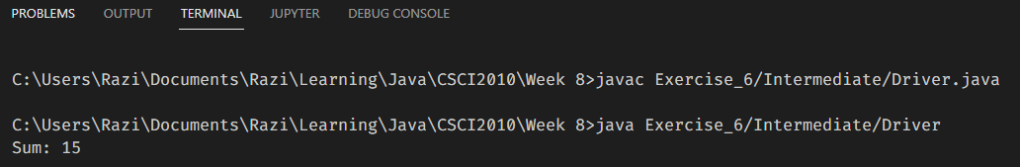

Try to run the program using commands in terminal to get more practice.

**Question 3 (Advanced)**

This exercise tests your knowledge of recursion in Java.

Write a Java program that creates a class Driver which has a main method that declares an int array which is then passed to a function called public static void reverseArray**(**int array**[],** int start**,** int end**)**. This function is expected to reverse the original array by modifying the same array. For example, if provided array is [1, 2, 3, 4], this function should reverse the same array and now the array should become [4, 3, 2, 1]. Also, find Big-O time complexity of this function.

Below is the expected output:

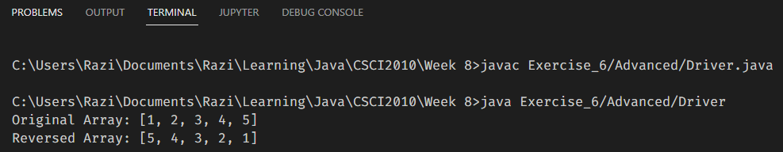

Try to run the program using commands in terminal to get more practice.